**SE SEM IV**

**Subject ITC 401: Engineering Mathematics IV**

**2024-25**

**March 2025**

**Title**: Mini Project for ITC 401 Engineering Mathematics IV

**Academic Year**: 2024-25

**Name of Team:** Infinity Squad

**List of Team Members:**

|  |  |
| --- | --- |
| **Members** | **Roll Numbers** |
| Harshal Bhosale | 7 |
| Shrinivas Bojja | 9 |
| Keshav Prajapati | 44 |
| Ojal Ramteke | 46 |
| Cyril Sibichan | 55 |
| Ryan D’Souza | 65 |

**Table of Content:**

|  |  |  |
| --- | --- | --- |
| **Sr. No** | **Content** | **Page No.** |
| 1. | Acknowledgement | 2 |
| 2. | Abstract | 2 |
| 3. | Introduction | 2-3 |
| 4. | Information Gathering and Analysis | 3-6 |
| 5. | Contributions | 7 |
| 6. | References | 7 |

**Acknowledgement:**

We, as a group, would like to express our sincere gratitude to **Dr. Revathy Sundararajan** from the **Department of Basic Science and Humanities** for her invaluable guidance and unwavering support throughout this project. Her insightful advice, encouragement, and expertise have been instrumental in its successful completion. Her dedication and willingness to assist at every stage have truly been a source of inspiration. We are deeply grateful for her time, effort, and valuable suggestions, which have significantly contributed to the quality of our work.

**Abstract:**

This project investigates the statistical distribution of even numbers in randomly generated one-digit numbers through repeated trials. Initially, 100 one-digit numbers were randomly generated, and the frequency distribution of digits was analysed. The number of even numbers in this set was recorded. The experiment was repeated for multiple trials (10, 20, 30, ..., 1000), and the distribution of even-number occurrences was studied. Data visualization techniques, including **frequency curves, bar charts, and statistical plots**, were used to analyse the trends. The results demonstrate that while individual trials show some variation, the distribution stabilizes with more trials, converging toward a **Binomial distribution** initially and approximating a **Normal distribution** as the number of trials increases. These findings align with the **Law of Large Numbers** and the **Central Limit Theorem**, making this study a valuable practical example of probability and statistical principles.

**Introduction:**

**Problem Statement:**

aim to analyse the frequency distribution of randomly generated one-digit numbers and investigate the occurrence of even numbers over multiple trials.

The key problems we address in this project are:

1. Understanding Random Distribution: How are single-digit numbers distributed when generated randomly?
2. Even Number Frequency Analysis: How often do even numbers appear in a set of 100 randomly generated digits?
3. Effect of Increasing Trials: What pattern emerges as we increase the number of trials from 10 to 1000 and beyond?
4. Identifying the Distribution: Does the obtained data follow a known statistical distribution, such as a normal or binomial distribution?

**Why are we making this project?**

Random number generation is fundamental in various fields, including cryptography, simulations, data science, and machine learning. By systematically increasing the number of trials and analysing the frequency of even numbers, we can observe how data behaves over repeated experiments and whether it follows a predictable distribution. This project also helps in developing skills in data visualization, probability analysis, and computational techniques, making it a valuable exercise in both theoretical and applied statistics.

**Challenges Faced:**

While conducting this project, we encountered several challenges:

* Random Number Generation Consistency: Ensuring uniform randomness in number generation was essential to maintain the accuracy of our analysis.
* Data Visualization: Plotting accurate and interpretable graphs required proper scaling and labelling.
* Statistical Interpretation: Identifying the underlying probability distribution required careful observation and understanding of statistical concepts.

**Information Gathering and Analysis:**

For this project, a structured approach was followed to collect, analyse, and interpret data regarding the frequency distribution of even numbers in randomly generated one-digit numbers. The methodologies applied include **random number generation, data recording, statistical visualization, and inference based on the observed distributions**.

**Methodologies Used**

**1. Random Number Generation**

The experiment required generating random one-digit numbers (0–9) and counting how many of them were even (**0, 2, 4, 6, 8**). This was done using a computational approach where a random number generator was used to simulate multiple trials.

* **Step 1:** Generate 100 one-digit numbers in a single trial.
* **Step 2:** Count how many of these numbers are even.
* **Step 3:** Repeat for multiple trials (10, 20, 30, ..., 1000).
* **Step 4:** Store results for statistical analysis.

**2. Data Collection and Organization**

For each trial, the number of even numbers obtained was recorded. The results were systematically stored in tables and spreadsheets, ensuring accuracy in tracking the frequency of different outcomes.

**Key Data Points Recorded:**

* Number of even numbers per trial.
* Frequency of occurrences for each count.
* Variations across increasing trial sizes.

**3. Graphical Representations and Their Conclusions**

**(a) Histogram: Even Number Count vs Frequency**

A histogram was plotted to visualize how frequently different counts of even numbers appeared in each trial.

**Observations:**

* The most common count of even numbers per trial was around **50** (since the probability of a number being even is 50%).
* The distribution was approximately **bell-shaped**, meaning most trials had even counts clustered around the mean, with fewer extreme cases.
* As the number of trials increased, the shape of the histogram became **smoother and more symmetric**, resembling a **normal distribution**.

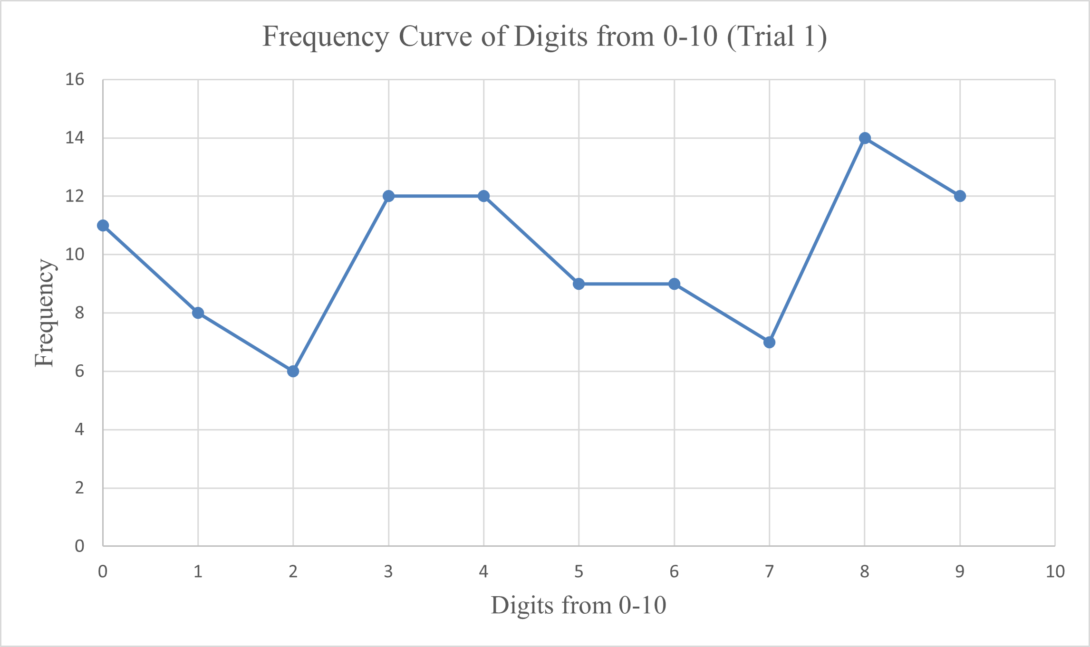

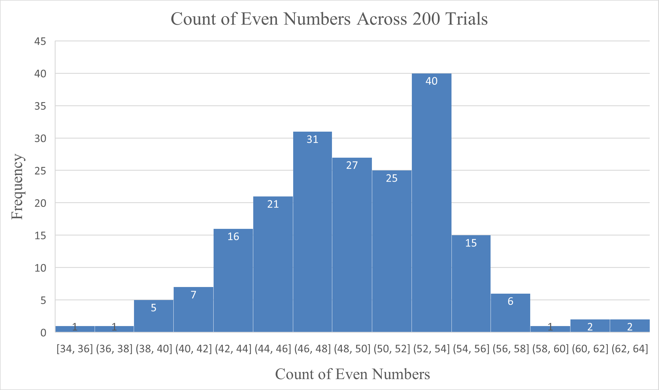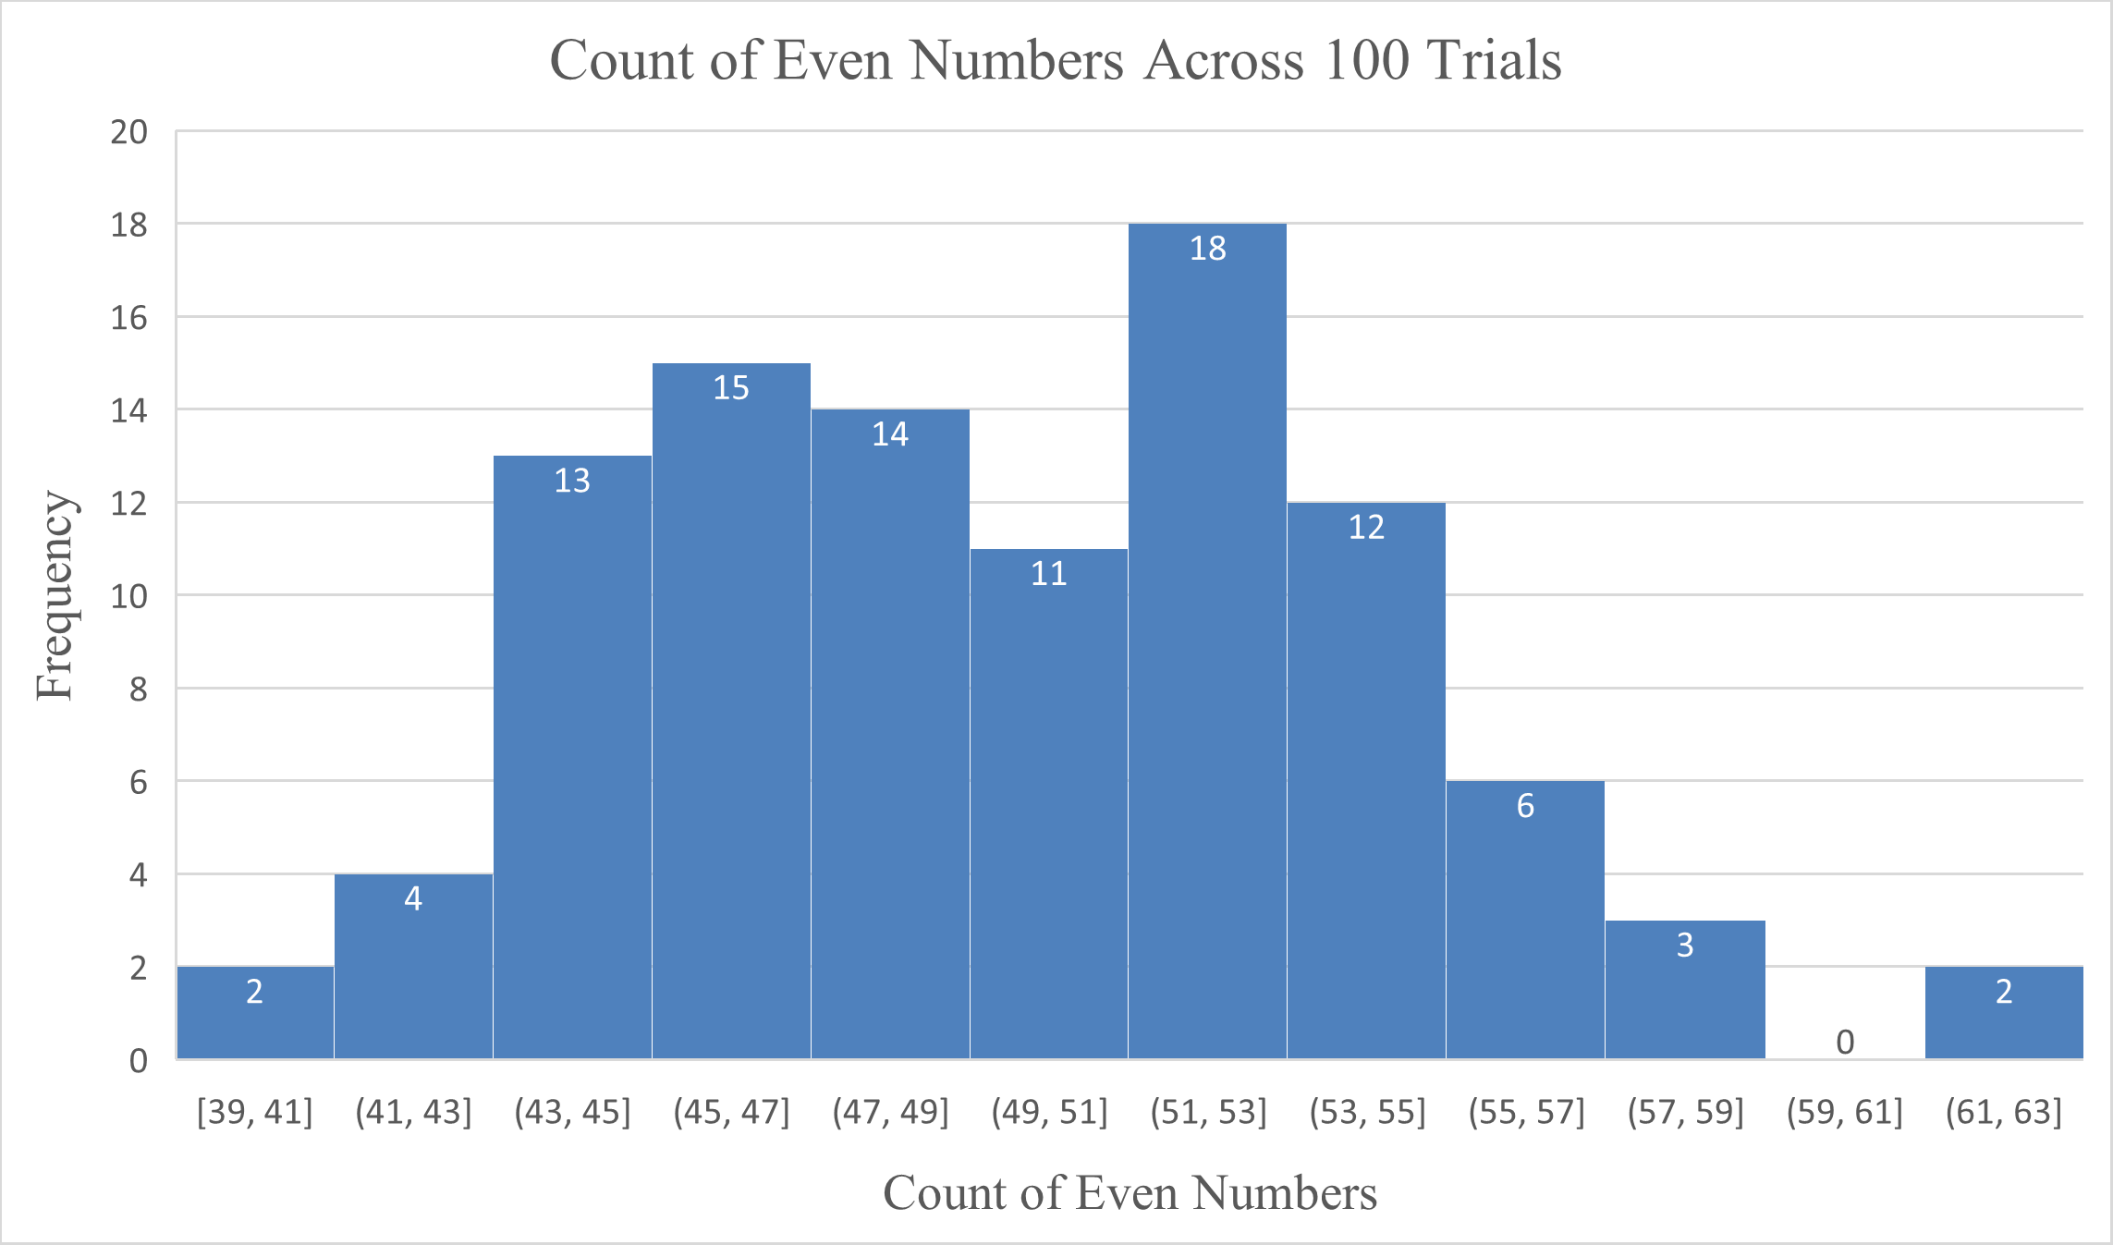

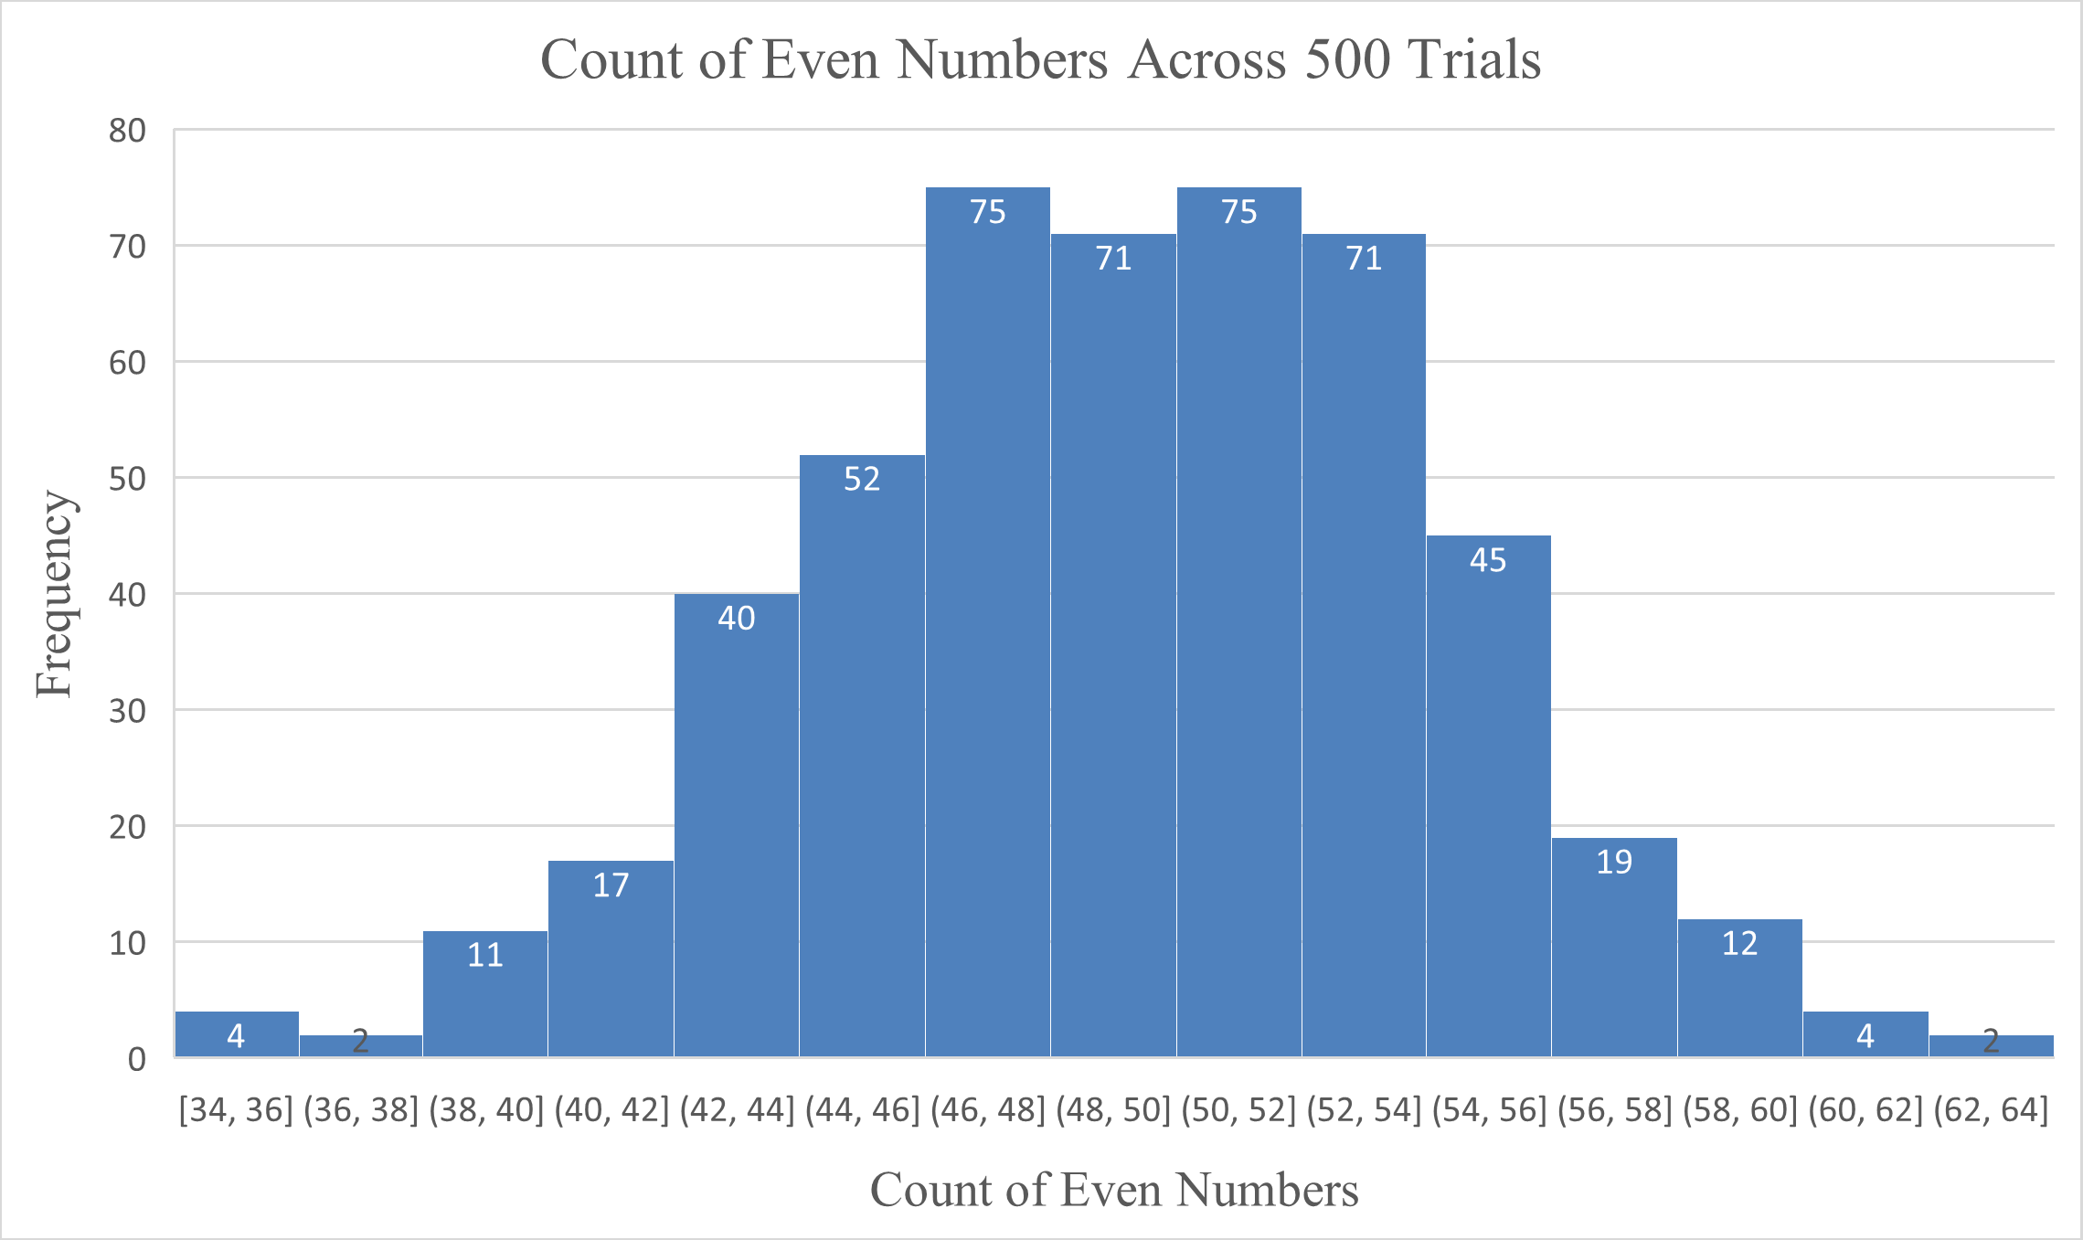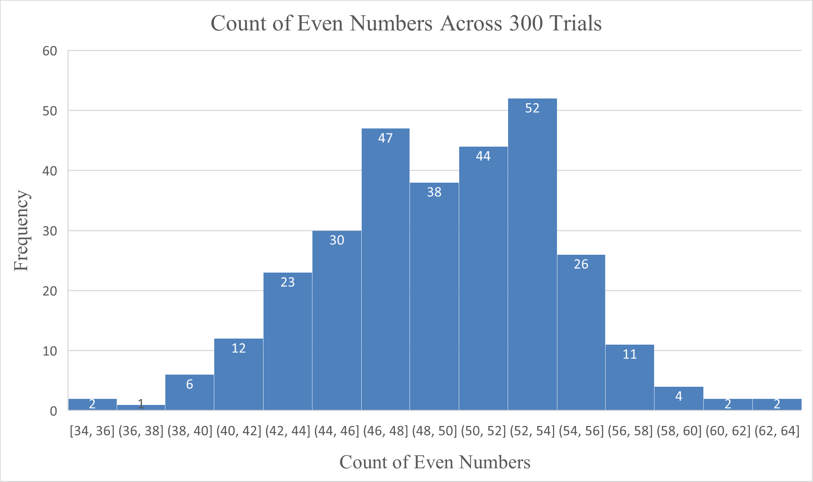

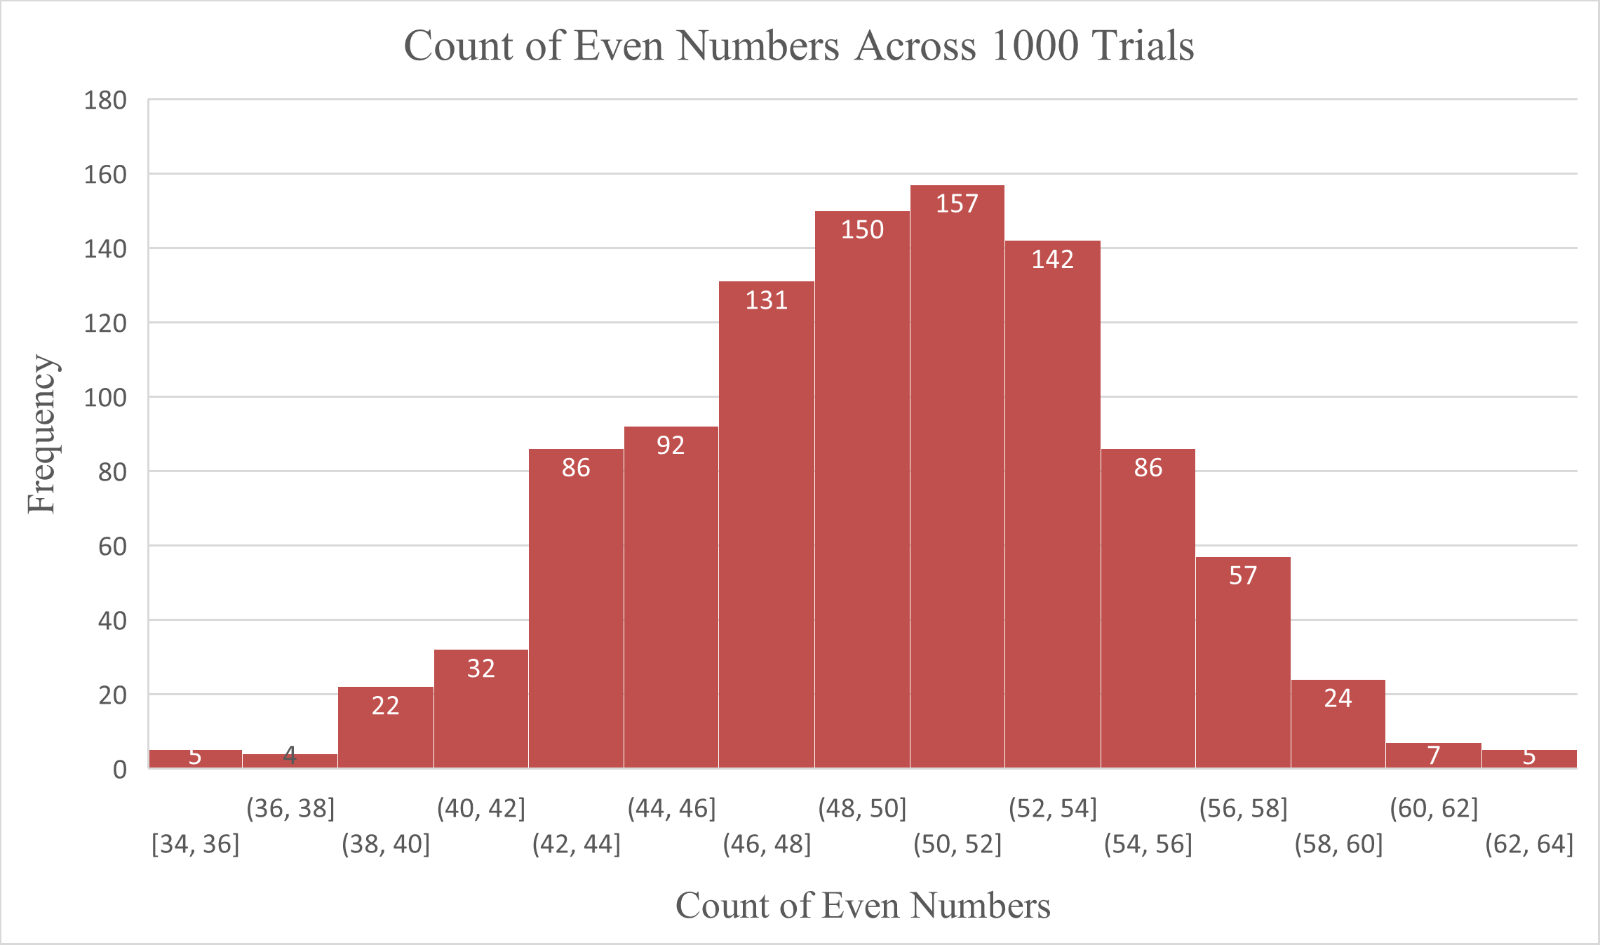

**(b) Frequency Curve: Count vs Trial Size**

A frequency curve was drawn to analyse the variation of even-number occurrences as the number of trials increased.

**Observations:**

* Initially, with fewer trials (10, 20, 30), the data showed fluctuations in the counts of even numbers.
* As more trials were conducted (100, 500, 1000), the frequency distribution stabilized, further confirming a normal distribution pattern.
* This indicated that as the number of trials approached infinity, the results would converge to a predictable statistical pattern, supporting the **Central Limit Theorem (CLT)**.

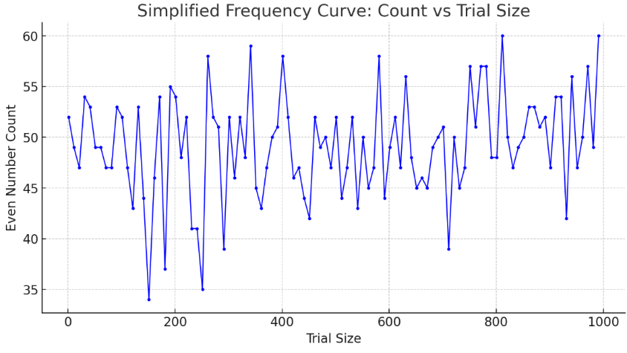

**4. Inferences Drawn from the Analysis**

1. **Statistical Consistency:** Over a large number of trials, the even-number count consistently centered around 50 (expected value for 100 random digits).
2. **Normal Distribution Behaviour:** The distribution of even-number occurrences followed a Gaussian (normal) distribution, meaning the probability of getting a count far from 50 decreased symmetrically.
3. **Law of Large Numbers:** The more trials conducted, the closer the observed results matched the expected statistical distribution, demonstrating that randomness evens out over time.
4. **Real-World Applications:** This experiment reflects real-world scenarios such as system reliability, performance modelling, and data analytics, where distributions help in predicting probabilities and making informed decisions.

**Conclusion**

The experiment successfully demonstrated the emergence of a **normal distribution** when counting even numbers in randomly generated digits across multiple trials. The use of histograms and frequency curves provided clear visual confirmation of statistical principles like the **Law of Large Numbers** and the **Central Limit Theorem**.

**Contribution of each Team Member:**

**Acknowledgement and Abstract:** Shrinivas

**Introduction:** Ojal and Cyril

**Information Gathering and Analysis:** Keshav and Harshal

**Conclusion and Inferences:** Ryan

**References:** Harshal

**References:**